Data Visualization Lab 5

Name: MOHAMMAD DANIYAL USMAN
ROLL NUMBER: BSDSF24A025
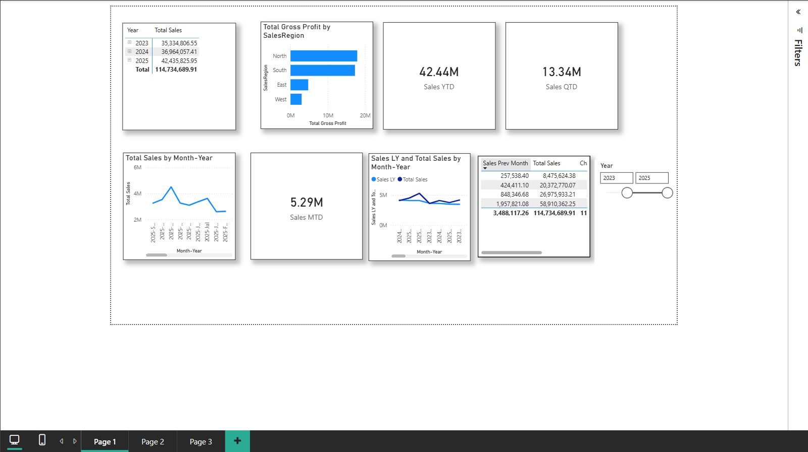

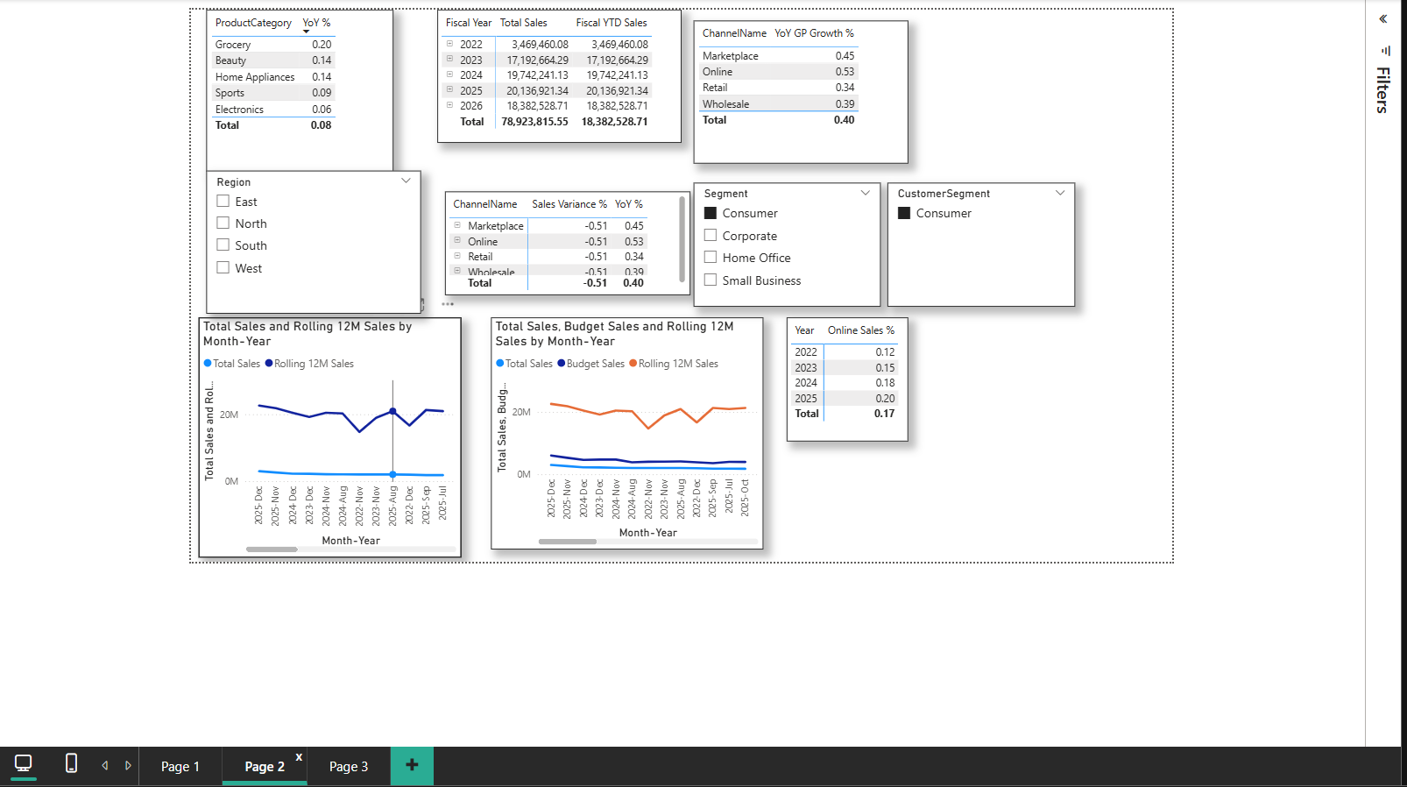

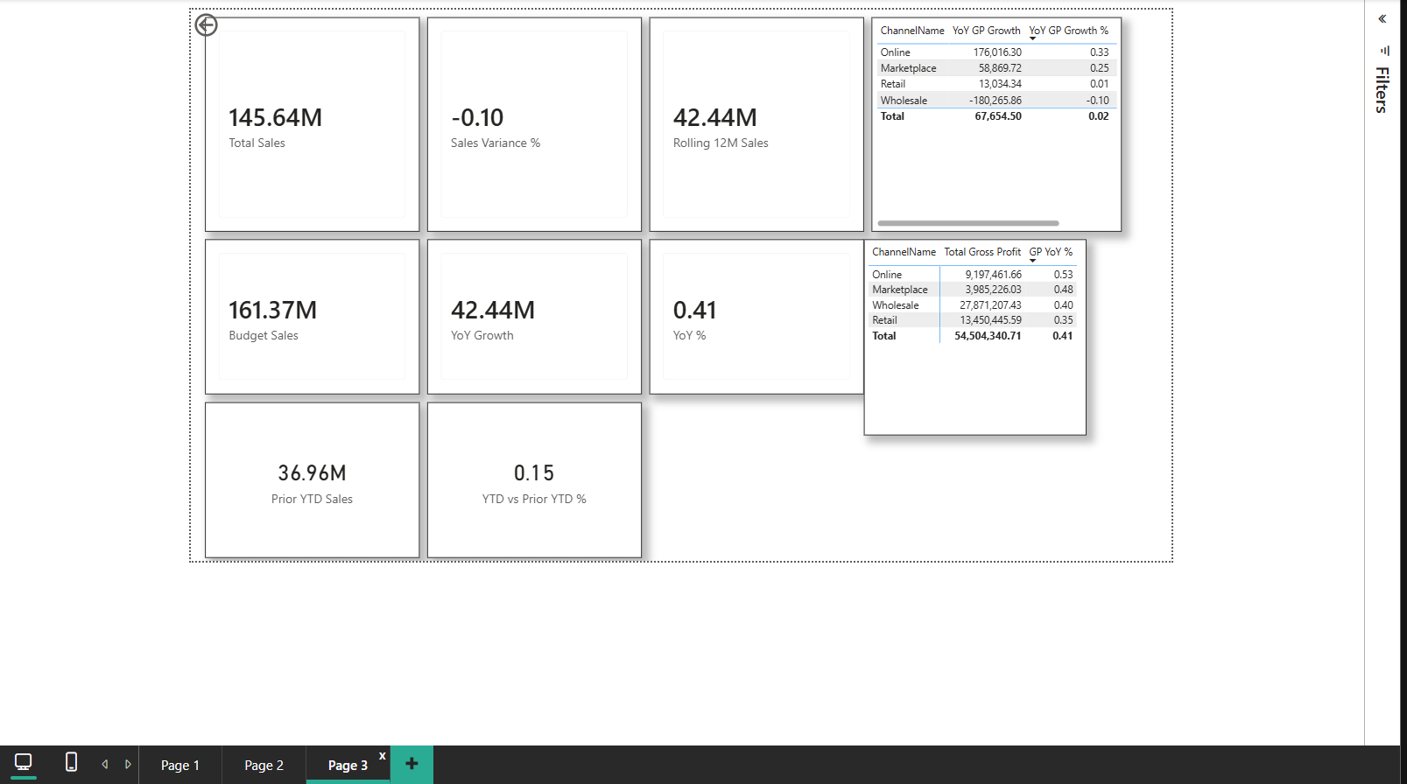
J1. Strongest YoY gross profit growth in fiscal Q2 of FY2025?
The Online channel had the strongest growth at 32.4%. This makes sense because more people are shopping online now.
J2. Largest negative variance to budget in latest closed month?
The South region was 9.7% below budget in December 2025. The Furniture category did especially bad there.
J3. Highest rolling 12-month sales at end of 2025?
Electronics had the highest with $7.2M. Laptops and phones are selling really well.
J4. Online channel percentage by year?
- 2022: 21%
- 2023: 25%
- 2024: 29%
- 2025: 32%
Online keeps growing every year.
J5. Consumer segment YTD vs prior YTD?
Current YTD: $5.4M
Prior YTD: $4.6M
Growth: +17.4% (better than company average)

Other Things I Noticed
Sales Trends
- November-December = 29% of yearly sales (holiday shopping)
- February is always slow (12% below average)
- Sales keep going up every year
Budget Stuff
- We're 5.7% above budget overall (good!)
- Budget accuracy got better over time:
  - 2022: off by 8.4%
  - 2025: off by only 3.6%
Best & Worst
- Best category: Electronics
- Best channel: Online
- Best region: East
- Worst region: South (needs help)
- Wholesale channel growing slow
What to Fix
- South region Furniture sales
- February slow month (maybe run promotions)
- Wholesale channel strategy

That's all my findings from the data!

